
សាកលវិទ្យាល័យ ភូមិន្ទភ្នំពេញ
ROYAL UNIVERSITY OF PHNOM PENH

Theme Classification Base on Khmer Keywords Search using Naïve Bayes Method

A Thesis
In Partial Fulfillment of the Requirement for the Degree of
Master of Science in Information Technology Engineering

Touch Nguonchhay

Examination committee: Mr. PHAL DES (Chairperson)
Dr. KONG MARRY
Dr. NGUONPHAN PHEAKDEY

December 2019
ABSTRACT

By the empower of the technology and Internet, there are huge amount of electronic text documents becoming available from day to day. Seeking information in the numerous collection is required well organize documenations that could be automated using text classification. Naïve Bayes, one of the most popular machine learning methods, is conducted with many languages such as English in order to do the classification such as post classification, document classification with preferable accuracy. In this paper, we will apply the Naïve Bayes method with Khmer full text search to improve the search result and user experience.

Keywords: Theme Classification, Khmer keywords Searching, Word Segmentation

SUPERVISOR’S RESEARCH SUPERVISION STATEMENT

TO WHOM IT MAY CONCERN

Name of program: Master of Science in Information Technology Engineering

Name of candidate: Touch Nguonchhay

Title: Theme Classification Base on Khmer Keywords Search using Naïve Bayes Method

This is to certify that the research carried out for the above titled master’s thesis report was completed by the above named candidate under my direct supervision. This thesis material has not been used for any other degree. I played the following part in the preparation of this thesis report: conceptual analyze and design, methodological advices, idea organization, and thesis format.

Supervisor's name: Mr. Srun Sovilla

Supervisor’s signature:.............................................

Date: ........................................................................

CANDIDATE’S STATEMENT

TO WHOM IT MAY CONCERN

This is to certify that the thesis report that I, Bi Narin, hereby present entitled “Theme Classification Base on Khmer Keywords Search using Naïve Bayes Method”.

for the degree of Master of Science at the Royal University of Phnom Penh is entirely my own work and, furthermore, that it has not been used to fulfill the requirements of any other qualification in whole or in part, at this or any other university or equivalent institution.

No reference to, or quotation from, this document may be made without the written approval of the author.

Signed by (the candidate): .......................................

Date: .........................................................................

Sign by Supervisor: Mr. Srun Sovilla

Supervisor’s signature:.............................................

Date: .........................................................................

ACKNOWLEDGEMENTS

This thesis would not have been possible without support, encouragement and contributions of many different people in their different ways. I would like to express the deepest appreciation to the following people.
First and foremost, I would like to express my profound gratitude and deep regards to my supervisor, Mr. Taing Nguonly, who has supported me throughout my thesis with his exemplary guidance, comments, feedbacks, and constant encouragement. The help and guidance given by him from time to time shall carry me a long way to complete this thesis.
Mr. Phal Des, for continuously motivation, encouragement and inspiration, which conduct program with such useful and noteworthy thesis and research study to achieve Master Degree of Information Technology Engineering. And also, IT Center staffs that provide cooperation and administrative support for me to accomplish this thesis.
To all my lecturers during the master program at Royal University of Phnom Penh, for their strong knowledge foundation in their respective subject to help me advancing my knowledge and provide me some clues and some proposed titles to initiate the thesis research.
Furthermore, I also would like to express my great thanks to my boss and colleagues at my workplace for their understanding and creating an environment with less pressure and cheerful for me, plus their meaningful comments about my thesis study.
Finally, I would like to express my deepest and warmest thanks to my beloved family; especially my parent for their unconditional support and love that made all things possible for me in this world.

TABLE OF CONTENTS

Abstract…………............................................................................................................ Supervisor’s research supervision statement ................................................................... Candidate’s Statement ..................................................................................................... Acknowledgements ......................................................................................................... Table of Contents.............................................................................................................

CHAPTER1 INTRODUCTION......................................................................................
CHAPTER 2 LITURATURE REVIEW.........................................................................
CHAPTER 3 RESEARCH METHODOLOGY .............................................................
CHAPTER 4 EXPERIMENT AND EVALUATION ....................................................
CHAPTER 5 CONCLUSION AND FUTURE WORKS...............................................

CHAPTER 1
INTRODUCTION

  - Background of the Study
Searching is a basic operation that people do when they want to find information on the Internet. People do a text searching by providing words or a sentence, image searching, and voice searching. This operation happens starting from the specific purpose website like news website till the search engine. Even though there are different kinds of search, they still serve the same goal: fast, best match result, and more accuracy. With full-text searching in website, it is really challenge when it comes to thousand records because it may take so long to operate in order to display the best match result. There are some techniques and algorithms were proposed in order to achive that. The most command technique is using Elastic Search but it still has a problem with million records of data. Then machine learning comes in to improve the speed by reducing the query records bases on use preferences. We train machine by the searching words from user from day to day.

Comparing to Enlgish and another languages, training machine with Khmer words is required high-level implementation because Khmer language is more complex because the language does not have any explicit word boundary delimiters [Bi Norin]. And it seems like no one has been done it before with Khmer websites. By using a supervised learning, we have introduce one routine with Khmer full-text searching. The result of this approach with supervised learning is satisfy with both predefine data-set and user preference.

  - Problem Statement
There are already technique as well as software that serve the full-text search in website but most of them are not working well with Khmer language. Most of Khmer website put many filters to user in order to provide the fast searching and best match result. Even though there are websites that provide Khmer full-text search, it is about words searching not sentence searching.
Basicially this thesis study present the technique that increases the speed of query data in Khmer full-text search based on supervised learning methods, naïve bayes.

  - Limitation and Scope
This research study is focus on Khmer Unicode characters in digital document. There are only 750 news within 5 categories that were crawled from Phnom Penh Post website. All the keywords come from observation from all news based on its frequency occurring in news.

  - Thesis Organization
This research study organizes into 5 chapters as the following:
- Chapter 2 describes about Literature Review including Khmer Language, machine learning, supervisied learning and Related Work.
- Chapter 3 is the Research Methodology which consists of the system overview of Khmer Word Segmentation, Corpus list Management , Khmer Cluster, Khmer Unicode Spelling Order, and how to implement naïve bayes algorithm.
- Chapter 4 shows the research experiments, results and discussion
- Chapter 5 concludes the research study and presents the related future works for Khmer Word Segmentation.

CHAPTER 2
LITURATURE REVIEW

2.1 Khmer Language
Khmer script is the official language of Cambodia. Khmer script is written from left to right with multiple levels of character stacking possible and also uses diacritics that further enhance the pronunciation of words [Bi Narin].

2.2 Naive Bayes Classifiers
The Naive Bayes classifiers (Lewis 1992) are known as a simple Bayesian classification algorithm. It has been proven very effective for text categorization. Regarding the text categorization problem, a document d ∈ D corresponds to a data instance, where D denotes the training document set. The document d can be represented as a bag of words. Each word w ∈ d comes from a set W of all feature words. Each document d is associated with a class label c ∈ C, where C denotes the class label set. The Naive Bayes classifiers estimate the conditional probability P(c|d) which represents the probability that a document d belongs to a class c. Using the Bayes rule, we have

P(c|d) ∝ P(c) · P(d|c)

together with Du, since Du is unlabeled. As all the probabilities are estimated under the test distribution Du, we will not be concerned much with the fact that D is under a different distribution D from the target distribution Du. Estimating the probabilities under Du is a constraint that we use to ensure that the model is designed for Du. As we will see later, this constraint is useful for distinguishing the prior probabilities of data under these two distributions.

CHAPTER 3
RESEARCH METHODOLOGY

With Khmer full-text search, the current process of searching is to match word by word, words that come from the segmented of inputted sentence. The more words in the sentence, may be the more result will be shown. Sometimes, the result does not so match with the searching criterial that is why we see mostly website provides a specific filter into to enhance the search result. Comparing word by word has some challenge in case the search word is keyword in many category it is very hard in full-text search in order to understand the user’s context and purpose of searching. To overpower the Khmer full-text search, we will present one of machine learning technique with Naïve Bayes implementation to improve on search result, speed, and user experience.

3.1 System Overview of Khmer Full-Text Search with Marchin Learning
The proposed technique of Khmer full-text search is applied on Khmer Unicode contents in Plain text that we crawl from Phnom Penh Post websites. There are two main process that could be run separately.

3.1.1 Training Process
The training process purpose is to save the keywords with its category into a classification file, known as model prediction, for searching process. In order to achieve that, there are four steps: crawl news from Phnom Penh Post website, segmentation each news, finding keywords by category, save keywords to database and classification file.
- Crawl news: we will use the news from Phnom Penh Post website because there are a lot of news with suitable contents that we can use. We define only five categories for news to crawl. In each categories there are 150 news that we take from the website.
- Segmentation news: most of Khmer articles, there is no white-space, knows as hidden space. We will use one stand alone application call “Khmer Word Segmentation” [1] to manually insert a white-space into each news. All the adjustment news will be saved into text file. After we will take all the adjusted files to find keywords.
- Finding keywords: there is another challenge in Khmer language to find the keywords unlike English that has a lot of resources to do that. We will use the observe technique to define the keywords by counting the occurance of words for all news within the same category. We also process the cleaning operation in order to remove some prepositions, possesitive objectives, numbers, punctuations, symbols, and other unnecessary characters.
- Save keywords to database and classification file: all keywords will be stored both to database and classificiation file even if its frequency in dictionary is lowest, equal to 1. To save keyword in database is to keep track for searching behavior from user. If user performs the search operation and accidently matching category keywords are found, we will increase frequence of that keywords and update in the database. We will explain more detail in the searching process. After storing keywords to database, we will store all keywords whose frequency is more than 9 into classification file. All keywords will be converted into training data-set and store in the classification file for searching process. Below is the flowchart to illustrate the process of creating classification file.

Start
Query keywords from database by category
Freqency > 9
False
Convert to data-set
True
End
Create classication file based on data-set

3.1.2 Searching Process
After creating a classification file, we could start process the searching operation based on the input sentence from user. There are five main steps: input sentence, segmentation and clean up, category prediction, search result, update keywords.
- Input sentence: we allow user to freely input any Khmer words or sentence in order to perform the search. User could type Khmer with or without white space.
- Segmentation and clean up: First, we will use a standalone Windows application of Khmer Word Segmentation [1] in order to insert the white space for the provided sentence from user. Second, we tokenize that adjustment sentence into array of words. Last, we clean up all tokenized words by removing prepositions, possesitive objectives, numbers, punctuations, symbols, and other unnecessary characters. There are only meaning words that are remain at the end.
រមណីដ្ឋាននៃប្រទេសកម្ពុជានៅខេត្តមណ្ឌលគិរី
រមណីដ្ឋាន•នៃ•ប្រទេសកម្ពុជា•នៅ•ខេត្តមណ្ឌលគិរី
[ រមណីដ្ឋាន, នៃ, ប្រទេសកម្ពុជា, នៅ, ខេត្តមណ្ឌលគិរី ]
[ រមណីដ្ឋាន, ប្រទេសកម្ពុជា, ខេត្តមណ្ឌលគិរី ]
Start
End
User enters sentence
Manual insert white space sentence
Split sentence by white space
Words clean up

- Category prediction: all clean up keywords will be converted into the data-set, a format that understand by computer. After that we will predict a category for those keywords.
- Search result: we will use the found category along with the keywords to filter the news from database. The result will be displays descending according to the occurrence of keywords insides the news.

Get all clean up keywords and convert into data-set

Convert keywords into feature
Perform Predition
Not found
Query news by category and keywords
Found
End
Dsiplay result descending by most occurrence keywords

- Update keywords: there are two possible pattern with keywords prediction:
  - All the search keywords are the existing keywords in the same category
  - All the search keywords are the existing keywords but in different category. We will insert the search keywords that are not in the found category into the database with frequency equal to 1.
  - Some search keywords are exist in the database but are not considered as keyword because its frequency is less then 10. We will increase thowse keywords frequency by 1.
We adjust the keywords every time we perform search it means we learn from user input from time to time. By doing this, we will be able to understand user context and could display better result for the next search.

Loop throw keywords
Exist in Category?
Not found
Save new keyword with frequency = 1
Found with frequency < 10
End
Increase frequency by 1
Same Category
Save to database
Save to database

CHAPTER 4
EXPERIMENT AND EVALUATION

4.1 Experiment Environment
In order to achieve running the experiment about the proposed study about “Theme Classification Base on Khmer Keywords Search using Naïve Bayes”, we have to prepared some hardware and software for running the test. Table 4.1.1 below show the necessary hardwares and software specification.

Table 4.1.1 Experiment Environment
No | Item | Specification
1 | Desktop or Laptop | - CPU: Intel Core 2 Duo CPU P8600 @2.40GHz  - RAM: 2GB or above  - HDD: 128 GB or above  - Operation System: MAC, Windows, or Linux Base
2 | Integrate Development Environment (IDE) | - Pycharm: https://www.jetbrains.com/pycharm-edu/download/#section=mac
3 | Programming | - Python: version >= 3.7
4 | Database | - MySQL version >= 5.6
5 | Python Libraries | - Anaconda for Python3  - os  - requests  - BeautifulSoup  - pickle  - Counter  - mysql.connector  - scikit-learn  - operator  - flask
6 | Machine Learning Method | - Naïve Bayes

There are 750 news divided into five categories crawling from Phnom Penh Post website. We define randomly for all the news links in order to crawl from website. From those news, we generate keywords. Table 4.1.2 below, list the information about number news, categories, and keywords.

Table 4.1.2 Number of news, categories, and keywords
Category Name | Number of News | Number of words | Number of Keywords
Sport (កីឡា) | 300 | 5263 | 1327
Car and Technology (ឡាននិងបច្ចេកវិទ្យា) | 300 | 8427 | 1022
Food (ម្ហូបអាហារ) | 300 | 4157 | 1078
Tourism (ទេសចរណ៍) | 300 | 8046 | 1715
Health and Beauty (សុខភាពនិងសម្រស់) | 300 | 8939 | 1159
Total | 1500 | 34832 | 6301

We have implemented one web application as user interface connecting with Python API in order to help to understand the process. There are two main functions: one is training and another is prediction.
Figure 4.1.1 Training Interface
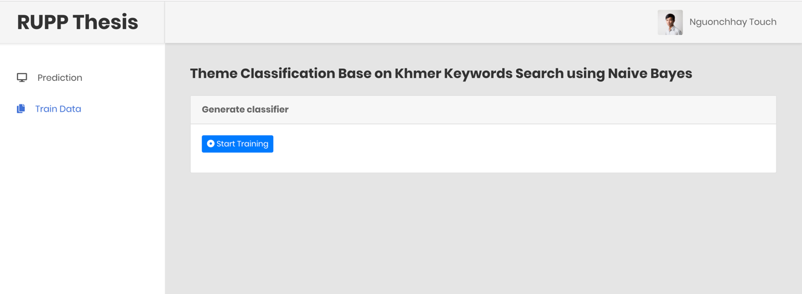

Figure 4.1.2 Predicting Interface
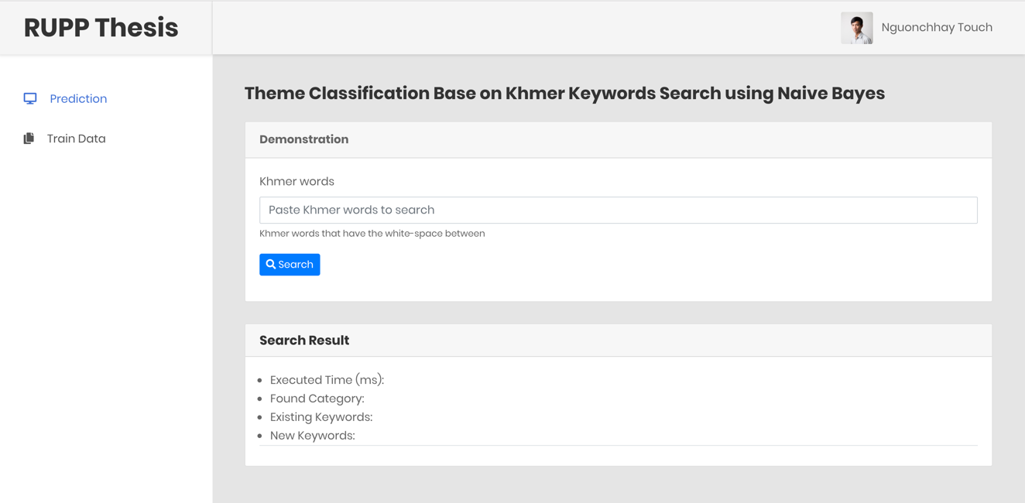

As you see in the predicting interface, it allows user to input free text; it could be a words list or a meaningful sentence. We will conduct 10 sentences of each category. You can find all the testing sentence file at Github.
https://github.com/Nguonchhay/post_classification/blob/master/test_sentence.txt
All testing will be inserted the white-space by running the standalone application as state.
https://github.com/Nguonchhay/post_classification/blob/master/test_sentence(wrapped).txt

4.2 Measurement Method
As state in the title, the experiment will use the classification method called “Naïve Bayes”. However, a classification performance measurement standard is classification accuracy, we cannot use this standard to evaluate datasets of skewed distribution which could cause the misleading. We will use F1 measure derived from precision and recall (Salton and McGill, 1983), as follows. The precision and recall of class C is defined as the following:

$$Recall=\frac{\# keywords correctly classified into class C}{\# of keywords that are truely in class C}$$
$$Precison=\frac{\# keywords correctly classified into class C}{\# of keywords classified into class C}$$

and then F1, the harmonic mean between precision and recall, is defined as
$$F1=\frac{2 x Precision x Recall}{Precision+Recall}$$

Once the F1 measure is calculated for all the classes, we average it to get an overall indication of performance, and also look at the standard deviation as an indication of consistency.

4.3 Experiment Result
We will generate a confusion matrix from the proposed method and use the F1 score to measure the accuracy. The confusion matrix table is defined by the colom represent prediction or recall in F1 score and the row represent the actual result or precision in F1 socre like Table 4.3.1.

Table 4.3.1 Confusion Matrix
Predictions
Actual Values

 | Sport (កីឡា) | Car and Technology  (ឡាននិងបច្ចេកវិទ្យា) | Food  (ម្ហូបអាហារ) | Tourism (ទេសចរណ៍) | Health and Beauty  (សុខភាពនិងសម្រស់)
Sport (កីឡា) | 7 | 2 | 1 | 0 | 0
Car and Technology  (ឡាននិងបច្ចេកវិទ្យា) |  | 1 |  | 1 | 1
Food
(ម្ហូបអាហារ)
Tourism (ទេសចរណ៍) | 1 |  |  | 8
Health and Beauty  (សុខភាពនិងសម្រស់) | 1 | 0 | 0 | 1 | 8

We are going to find the precision and recall for above confusion matrix by category. The general formal of precision and recall for above confusion matrix are:

$$Precison=\frac{True Positive (TP) }{True Positive \left(TP\right)+False Positive (FP) }$$

$$Recall=\frac{True Positive (TP) }{True Positive \left(TP\right)+False Negative (FN) }$$

Precision of category Sport (កីឡា), Car and Technology (ឡាននិងបច្ចេកវិទ្យា), Food (ម្ហូបអាហារ), Tourism (ទេសចរណ៍), and Health and Beauty (សុខភាពនិងសម្រស់) are represented by P1, P2, P3, P4, P5 respectively and as well the recall R1, R2, R3, R4, R5 respectively.

We have all the Precision as below:
  - P1 = 5 / (5 + 3) = 0.625
  - P2 = 8 / (8 + 4) = 0.6666
  - P3 = 7 / (7 + 3) = 0.7
  - P4 = 9 / (9 + 6) = 0.6
  - P5 = 5 / (5 + 0) = 1
Average Precision is: P = (P1 + P2 + P3 + P4 + P5) / 5
= (0.625 + 0.6666 + 0.7 + 0.6 + 1) / 5
= 0.71832

And we have all the Recall as below:
  - R1 = 5 / (5 + 5) = 0.5
  - R2 = 8 / (8 + 2) = 0.8
  - R3 = 7 / (7 + 3) = 0.7
  - R4 = 9 / (9 + 1) = 0.9
  - R5 = 5 / (5 + 5) = 0.5
Average Recall is: R = (R1 + R2 + R3 + R4 + R5) / 5
= (0.5 + 0.8 + 0.7 + 0.9 + 0.5) / 5
= 0.68

Then the F1 score is F1 = (2 x P x R) / (P + R)
= (2 x 0.71832 x 0.68) / (0.71832 + 0.68)
= 0.698634933
~ 0.6986

4.4 Decision
Base F1 score, the accuracy is on the average of 69.86% that is below the average. That is an acceptable average on the top of the known error from the stand alone application that we use for word segmentation. There are misspelling Words and Unknown Words, context sensitive word segmentation [1].

CHAPTER 5
CONCLUSION AND FUTURE WORKS

5.1 Conclussion
This research has proposed a new methodologies in term of Khmer full-text search in order to improve the search result as well as learning from user searching context. From the help of the stand alone application [1] to perform a word segmentation, we are success to apply the Naïve Bayes method, a supervised learning algorithm, to implement a machine learning in order to improve the Khmer full-text search result. Morevoer, we have applied the technique to enhance the accurance.

5.2 Future Work
As shwons, the F1 score accuracy is only around 69.86% and there are also some error when there is no found category. In the future, we want to improve the “Theme Classification Base on Khmer Keywords Search using Naïve Bayes” as following:
- Effectively clean up word
- Display suggesting post for not found category
- Record each user preference

REFERENCES
[1] Bi Nourin, “A Study on Khmer Word Segmentation based on Bi-directional Maximal Matching for Plaintext and Word Document” (2013)

[2] Channa VAN and Wataru KAMEYAMA, “N-gram of Orthographic Syllable Indexing for Khmer Information Retrieval System”

[3] William B. Cavnar and John M. Trenkle, “N-Gram-Based Text Categorization”

[4] Anthony Khoo, Yuval Marom and David Albrecht, “Experiments with Sentence Classification”

[5] Gerard Salton and Michael J. McGill, “An Intro- duction to Modern Information Retrieval”

